**NextTime App / Screenshots**

Landing page:

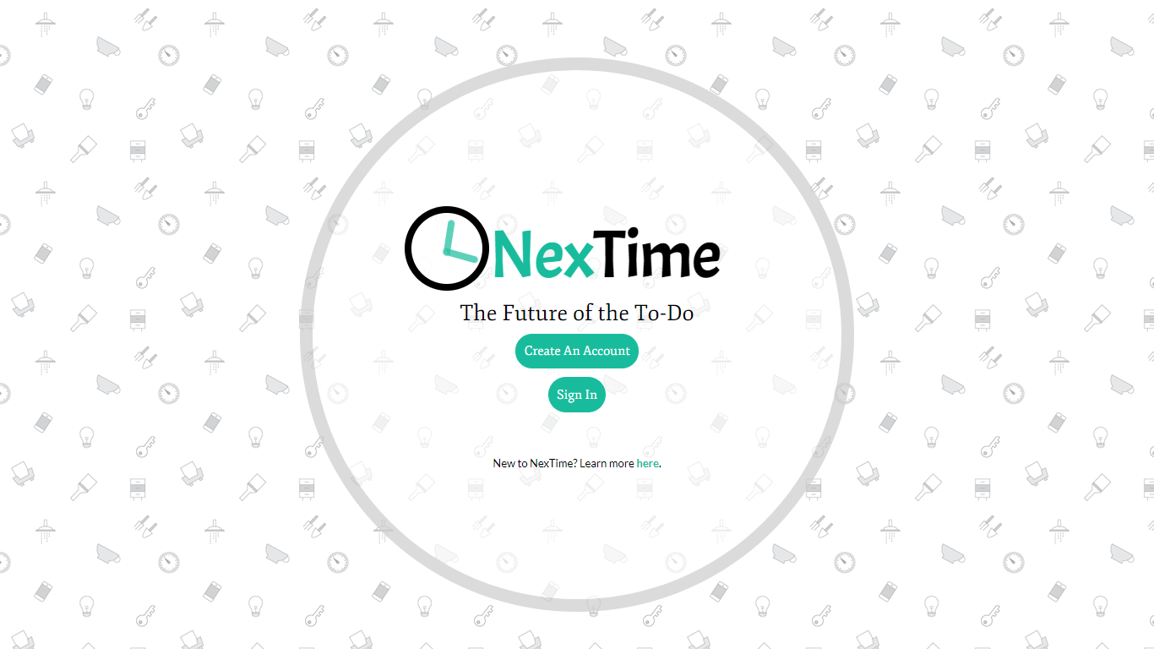

**NextTime App / Screenshots**

Create an account page:

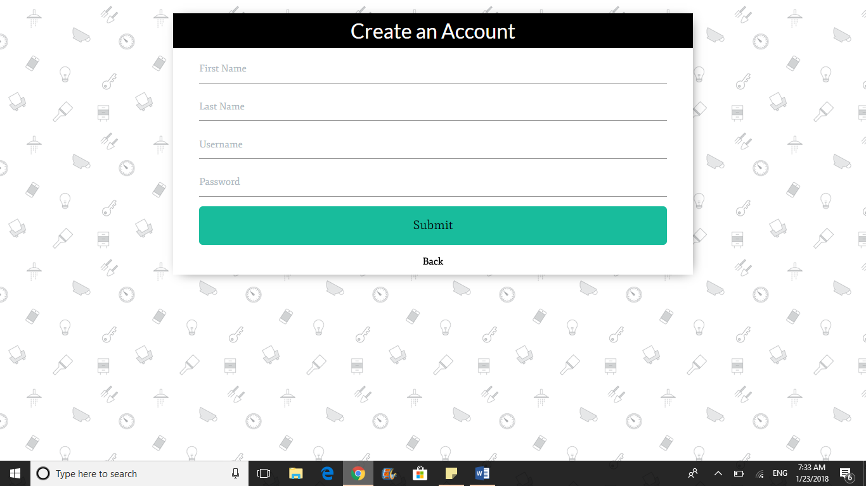

**NextTime App / Screenshots**

Login page:

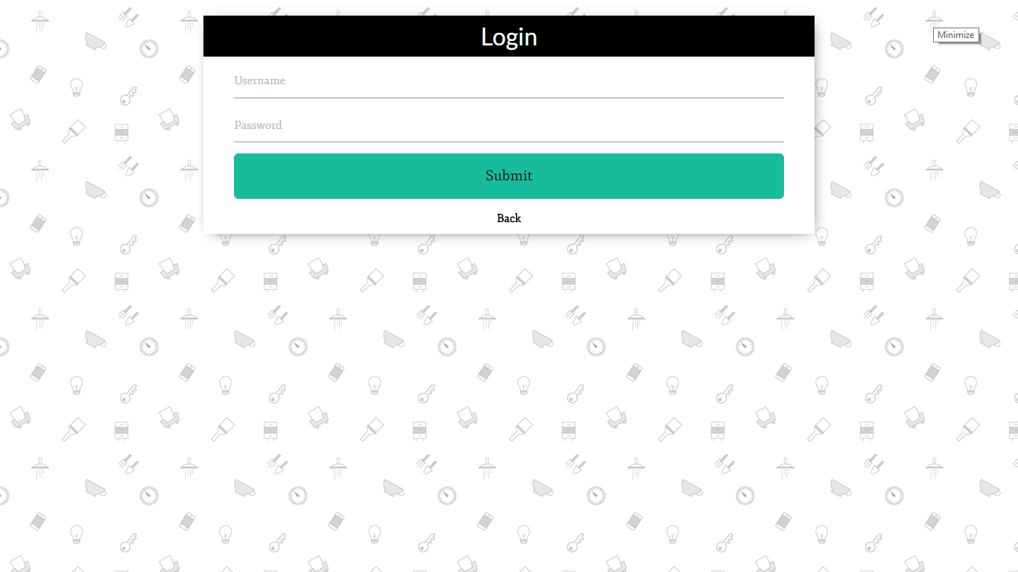

**NextTime App / Screenshots**

User home page (display of complete to-do list):

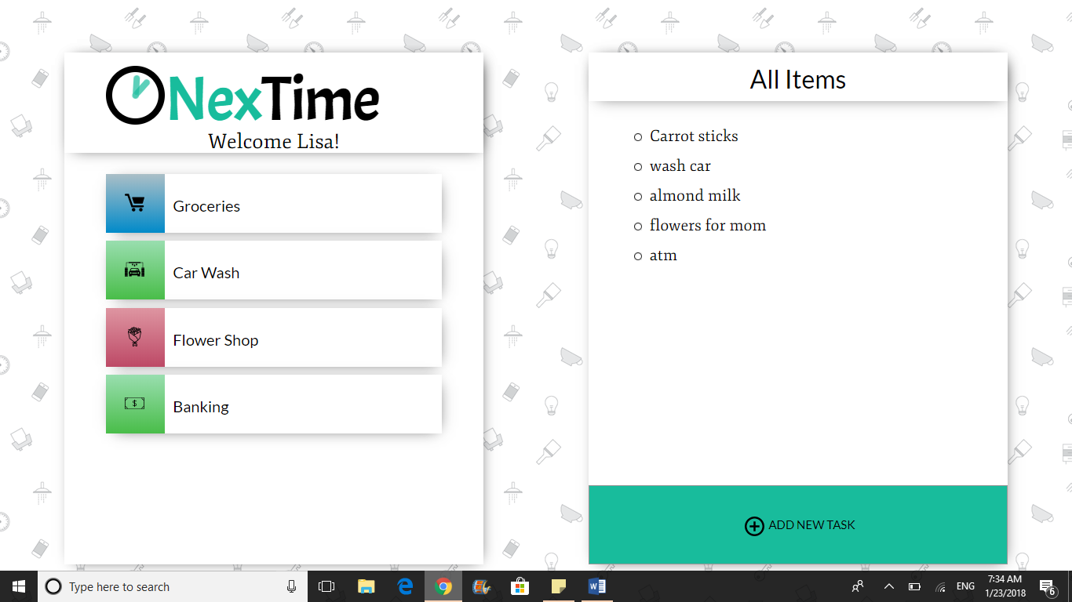

**NextTime App / Screenshots**

User home page (display of to-do list by category):

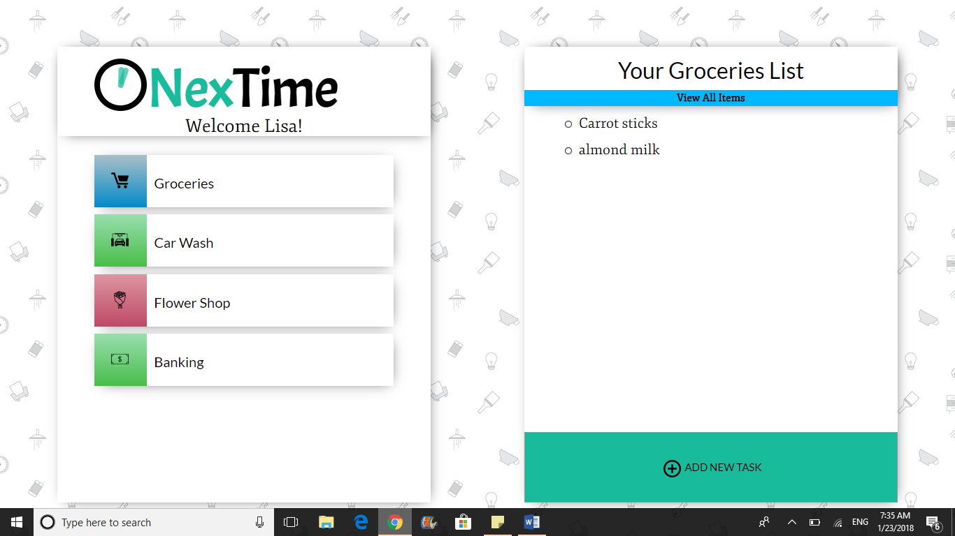

**NextTime App / Screenshots**

User home page (display of detailed view and update prompt):

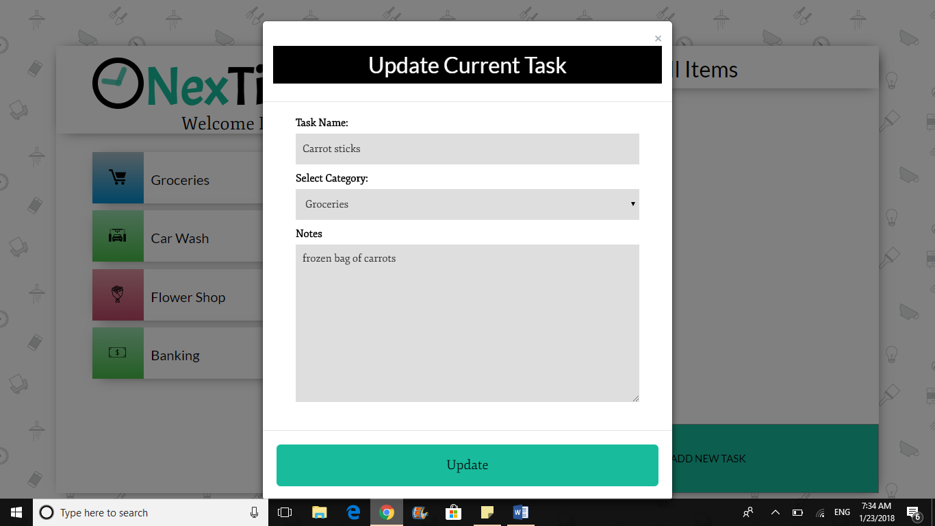

**NextTime App / Screenshots**

User home page (display of add new task prompt):

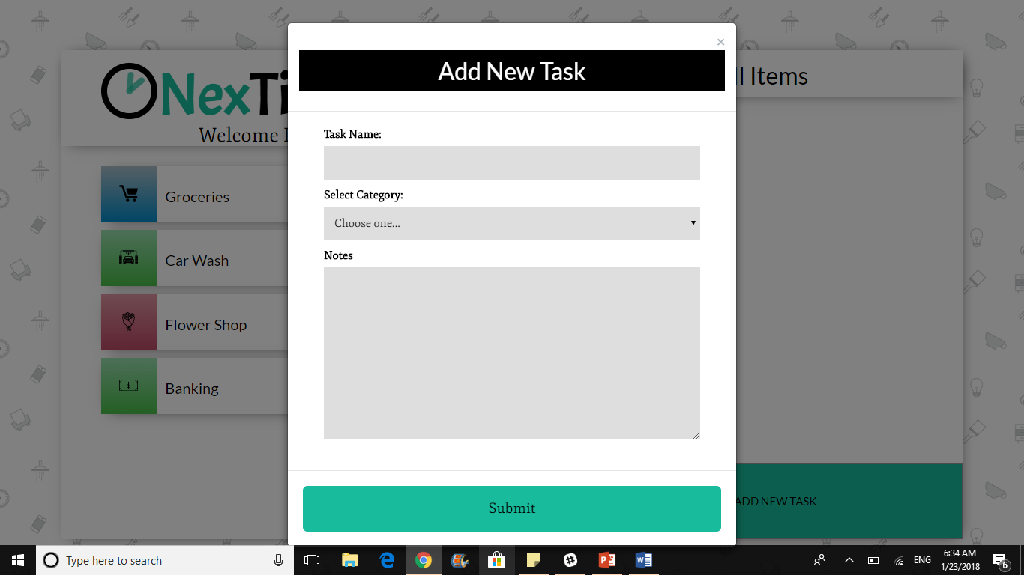

**NextTime App / Screenshots**

Notification modal:

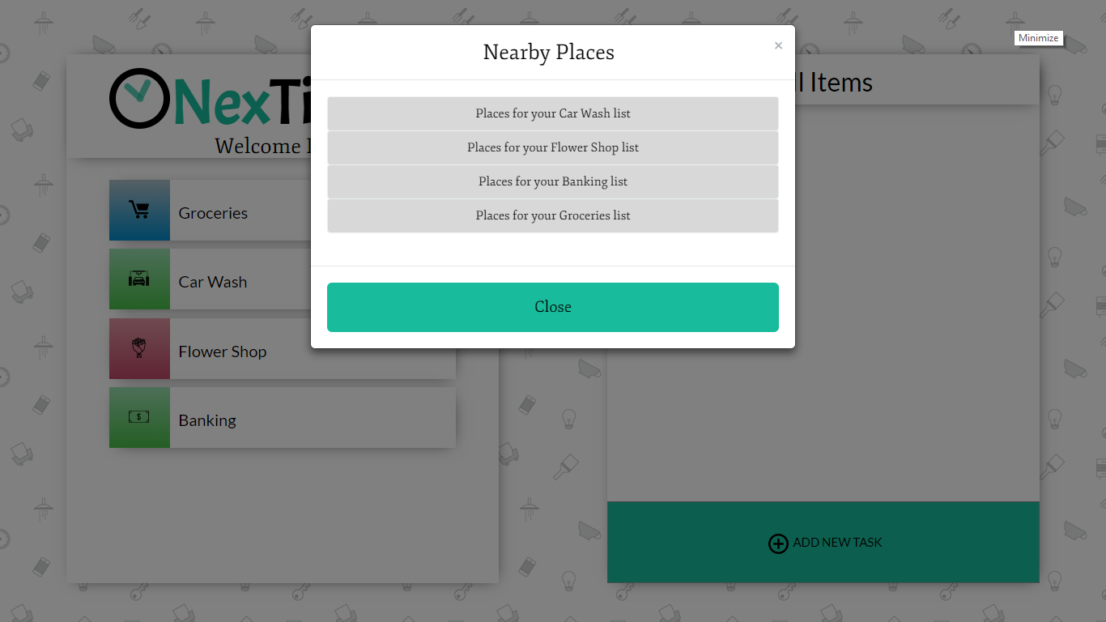

**NextTime App / Screenshots**

Display of notification modal (detail):

